Countryside on Lake Anna
Board of Directors Meeting Minutes

10:00 AM 08/09/09
399 Mountain View

Bill Malthouse, the President, called the meeting to order at 10:22 AM. Other officers attending were: Treasurer. Tom Nyman, and Secretary, Nancy Malthouse. Board members Steve and Donna Jenkins were also present.

Four officers missed the meeting: Chris Townes, Army Burroughs, Keith Yarnall, and Gary Schatz. A quorum was present to conduct business

Old Business

Prior Board Meeting Minutes
Minutes  03/22/09 | - Approved with minor cosmetic errors fixed. It was moved and seconded that the minutes be adopted. Passed.

Status Reports

Tom Nyman presented the Treasurer’s Report. 13 lots are still unpaid. A reminder postcard is to go out soon. Budgeted expenses are tracking actual expenses. Balance approximately $8,000.00.

Tom agreed to provide Bill the updated addresses and COLA Directory Opt In /Opt out.

Status of the POA Packages: Tom Nyman said he has a mystery note on his door yesterday. “Our names are Dottie and Tom. We bought the house on lot 13 owned by the Lowes. We were told that we could come here to pay the dues.” However, we have received a notice that somebody else bought that house. Donna said, “Army made a POA disclosure package.” But we still didn’t get any dues payment at settlement. We need to check with Army if we got any information at settlement. It is possible Army has a check. Tom looked up the owners names on the spreadsheet for (lot 11?) The owner of this lot is Christina Meller. They bought the lot on June 24, 2009. Bill suggested maybe renters left the note. They are $110.00 behind on the dues.

Deed Transfers: Tom Nyman said Donna’s sister’s lot is lot 57. They had transferred their portion of the Common Area already, so Donna’s sister didn’t have to do anything. She didn’t get a key though; apparently the prior owners didn’t have a key. Tom said she could see Army to get a key.

Service Award to Joe Madigan: Bill Malthouse reported that he prepared the award for Joe Madigan. Bill and Nancy Malthouse, Army and Judy Burroughs, and Steve and Donna Jenkins presented the award to Joe. He was really pleased.

The plaque cost about $60.00 ($10.00 over the agreed amount). Bill said he still needs to send the bill for the plaque and all the mailing for the last two years to Tom.

Dock Repairs: Steve Jenkins will honcho a group in the Fall (Prior to November of 2009).

Crew: Henry and the Nunleys have volunteered to help.

Decking: The 2008 decking plan is attached as page 3 of the minutes to be discussed at the Fall Board meeting.

The Boat Slip Mooring Posts hit rocks, were not installed deep enough, and are now laying on the ground. Army asked for an estimate on finger piers to stabilize the posts. The Zubers are the only ones with a boat there so far. Tom gave them permission to park it that way.

Ground undercutting from waves on left side of ramp behind the bulwark also needs repair.

Update/Distribution of Community Directories: Action: Since we are the ones who have the data on lot owners and Opt In/Out. Bill Malthouse decided he would update the directory prior to the picnic using the COLA spreadsheet containing the latest lot owner update and returned opt out data from Tom Nyman. Bill said he would update and distribute the directories at the Fall Steak Picnic.

New Business

Noise Abatement (Especially Renters) Recommendation: Bill Malthouse said he told the Potts to call the police. Donna said she also has trouble with dogs barking and noise across the street from her.

Donna and Steve also complained about the fence on the Powers’ lot next to Paul and Beth Gadocis being down for over a year, and Steve complained about Bernard Carr’s appliances on the porch and junk cars in the yard. Steve said he would call the County again about the junk cars.

Pilot of Lien/Collection Process: Tom Nyman will file a lien on lot 37, the Brummit’s lot. This lot has been unpaid for 10+ years. It is abandoned and the owners are surrendering the lot for sale to pay the taxes. The process is: the Settlement attorney makes an effort to collect back taxes. If they fail, then the lot is auctioned off. Their auction requirement is to collect at least enough money to pay the taxes. They wouldn’t discuss whether liens would be paid or not. Filing the lien will cost us $21.00

Lloyd’s Lots - In 2005, Donald Lloyd bought the lot that didn’t perk from the developer for $5,000.00. (Now, they could use a pressurized sanitary system.) The lot is now appraised for $20,000.00. We weren’t informed about the sale, however, so in 2006 we asked the developer for a contribution and got $100.00. Tom said he sent a welcome letter to Lloyd and by the way the dues are in arrears.

Bill added that Tom is worried about the property sale because we are concerned that Lloyd will build a road across that land to reach the new lots he is selling in Sassafras Cove. Tom said he believes that this is possible because Lloyd also owns the 5 foot strip between the lots on Mountain View Road and his lots in Sassafras Cove all the way from 522 down to the water. The BOD discussed this for several minutes and attempted to clarify whether Lloyd would also have to cross some of Bazenella’s land too. Apparently, Lloyd can build a road if he wants to do that.

Fall Steak Picnic September 19, 2009 at 2:00 PM: (Changed from Sept. 12 due to Malthouse’s schedule conflicts) Bill to provide postcard reminder of date and time; and “bring a dish to share”. If it rains, we will move the picnic to our house.

Responsibilities: Bill: Steaks & Beer; Donna & Steve, hot dogs, buns and condiments; Bill, Tom Army: Grills.

Rekeying the Common Area Lock: Army will acquire another lock and new keys. The key distribution is planed for the Fall Picnic, then 2 weeks later, the new lock would be changed. This will be done in the Spring.

Long Range Plans for Dock Area Improvement & Expansion: Steve said he thinks we will have a continuing problem with the docks because of the angle. Bill said he thinks we need to tee out from the existing docks (like a “Z” shape). Tom said we should establish a committee to study various plans. There may be rock in the lake out from the big rock at the end of Sassafras Cove. Steve agreed to call some dock builders around the lake to get some ideas on a plan. Kieth works at the power plant and may know someone. Also, George may have some ideas.

Set Next Board of Directors Meeting: Sunday October 4, 2009 @ 399 Mountain View, 10:00 AM.

Common Area Sign Steve went to Freshwater Estates and found a reasonable set of rules. Steve presented a picture of the rules we could use for our Common Area. This picture is incorporated as page 4 of the minutes. We proposed putting a sign like this next to the gate.

The following other additions to the sign were discussed:
Please keep the gate closed and locked at all times.
Guests must be accompanied by lot owner at all times.
Entire Area is a no wake/no swimming zone for your safety.

Steve will ask around for bids. The example sign in the picture is about 4’x 6’.

Adjourn 11:40AM
Respectfully Submitted
Nancy Malthouse, COLA Secretary
- Measure for total footage of pressure treated 2x4’s to be attached to existing stringers for nailing of new decking. – Steve J.
- Measure for total footage of pressure treated 2x6’s to be cut and used as decking (additional to the 26 5 footers Bill M. has at his house). –Steve J.
- Calculate amount of galvanized deck screws required to attach decking. Six screws per decking piece, 60 2 ½ inch deck screws per pound – Approximately 360 screws or 6 pounds – Or we can nail the decking using pneumatic nailers which will certainly be quicker but harder to remove if the need arises. - Steve J.
- Purchase materials from Purcell Lumber (10% discount) I need a Purcell card. – Steve J.
- Announce our intention to re-deck the dock and ask for volunteers and set a date for the work at the Fall Picnic. – Bill M.
- Deliver materials (2x4’s, 2x6’s, and screws) to common area on work day. –Steve J.

Re-Decking Plan
Start at dock end farthest from shore and remove the old decking from between two finger piers. With one person on each finger pier place new 2x4 on inside of existing stringer and nail/screw to stringer. If we have enough volunteers this could be completed simultaneously on the other side or the people on the finger piers will have to work their way to the other side and repeat the process. For the middle stringer, place loose deck boards on the stringers (2 per person should be sufficient) and use these for footing while attaching new 2x4. Once all three new 2x4’s have been attached to the stringers nail/screw new deck boards in place to the new 2x4’s. Repeat for next section between finger piers.
See diagram below.

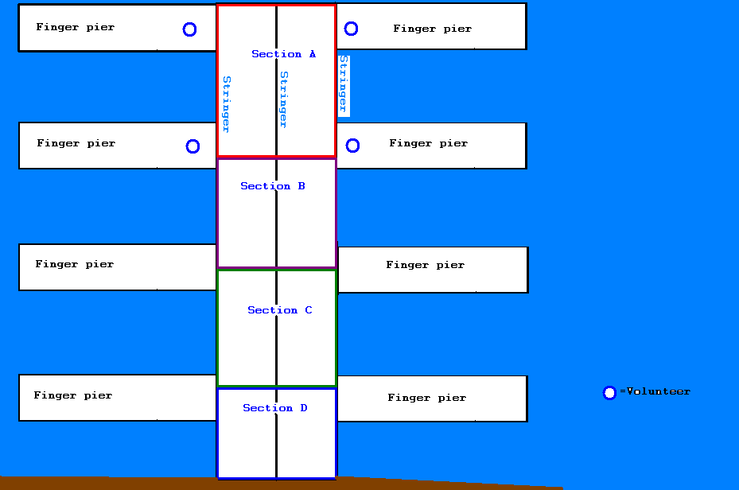

Tools/Equipment needed:

Generator to run compressor for nail gun, saw. - Volunteer
Power Drills/screwdrivers – I have 2
Tape measure – I have 2
Nail gun and compressor – I have 1of each
Hammers – I have 2
Pry bars (removing old decking) – I have 2
Power miter saw and/or circular saw – I have 1 of each.
Steve Jenkins, scjenk@wildblue.net
