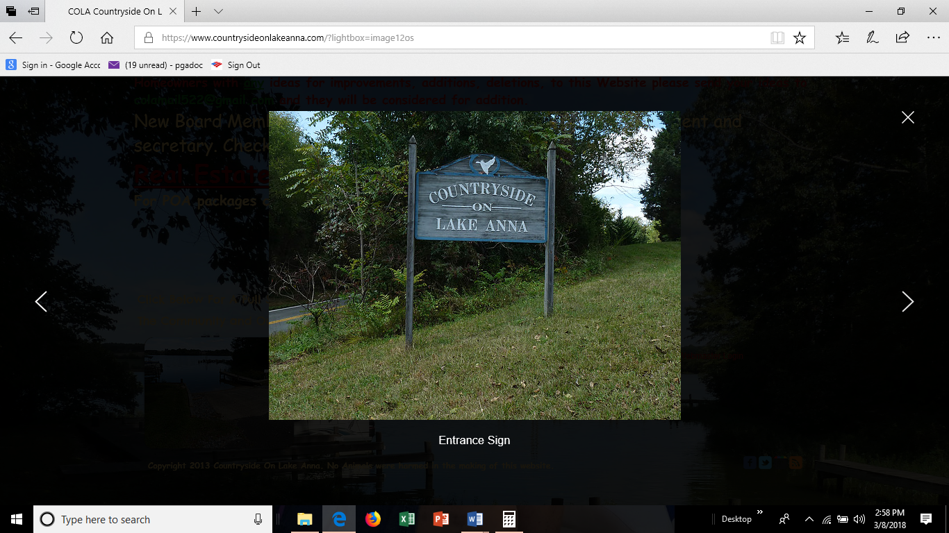

**COUNTRYSIDE ON LAKE ANNA**

**SPRING 2019 NEWSLETTER**

**COUNTRYSIDE GENERAL MEMBERSHIP MEETING and PICNIC**

Our annual meeting is scheduled for Saturday, May 25, 2019 at 10:00 AM in the common area. All residents and lot owners are urged to attend. Updates on our budget will be presented, maintenance projects will be reviewed, and an election will be held for Board of Director positions.

After the meeting we will have our annual picnic. Hamburgers, hotdogs, and beverages will be provided. All pot-luck side dish, salad or dessert, contributions are welcome.

**ANNUAL ASSOCIATION FEE**

The annual association fee is $125.00 per lot whether it has a house or is undeveloped. Lot fees for 2019 need to be paid by May 25, 2019or a late fee of $10.00 will be applied. Just as a reminder, use of the common area, boat ramp and slips are only available to owners that are current with their annual fee.

**COMMON AREA ACCESS**

The property title covenants dictate the common area is for use only by owners in good standing and guests accompanied by a lot owner. An ongoing problem is the failure of common area users to lock the gate after opening it. In order to minimize the unauthorized use of our facility by ineligible people, plus protect our insurance liability coverage, we must keep the gate CLOSED and LOCKED when not in active use.

Active use means that a boat is being launched or recovered; the launch vehicle arrives, opens the gate, launches or recovers a boat, and then leaves the common area locking the gate.

We are not planning on rekeying the gate this year but if there is abuse of the area we will be forced to rekey. Everyone receives one key per lot, replacement keys will be at a cost of $100.00 each.

**BOARD OFFICER UPDATES AND OPEN POSITIONS**

During our 2018 annual meeting officer elections were held. The board currently consists of the following owners: Donna Jenkins – President, Paul Gadoci – Vice President, Tom Nyman – Treasurer, Cathy Delozier – Secretary. Other board members include: Steve Jenkins, Beth Gadoci, Joe Holter, Dotti Henry, and Ted Tremain.

There will be four Board member slots up for reelection this year. Please let a board member know if you are interested in any of these positions. You are more than welcome to throw your hat in the ring as long as you meet the criteria.

Typically it is a mere 12-14 hours per year to attend meetings and you can make a positive impact on our community.

To be a board member you must meet the following criteria –

* Your property association fees must be current
* Your share of the common area must be deeded to the association (this is to your benefit since the association insurance covers you)

**BOAT SLIPS**

As in previous years, boat slips are rented to members in good standing on a first-request first-assignment basis. The rental fee for 2019 season is $125.00 for the 12 months ending May 25, 2020.Payment is due by May 25, 2019. Please indicate your interest in renting a slip in the bill’s return reply section.

For owners who rented a slip in 2018, board policy will allow automatic renewal for 2019 under the following provisions: (1) inform the association of your intention to renew before May 25, 2019, and (2) have a paid up account balance for lot fees as of May 25, 2019.

Rent payment not received by the due date will indicate the owner has decided not to renew and the slip will be released for other owners to rent it. Slips are assigned by the date of request application. If fewer than 12 automatic renewals are in effect and additional requests exceed a total of 12, there will be a lottery for the slips in excess of the total automatic renewals up to the available 12.

It has been mandatory for boater’s tying up to the slips to have snubbers. We still have many people not in compliance. This year if you do not have snubbers, you will not be eligible to rent a boat slip. (A snubber is a boat line that stretches to absorb shock. These are available at Overton’s for $8 to $15 each.)

**ASSOCIATION FINANCIALS**

**Reserve Account** - The association owns and maintains a number of capital assets, such as fences and gates, asphalt driveways, launch ramp, bulkheads, docks, boat slips, no-wake buoys, trails and trees. Repair and replacement costs—when needed—are paid for from our Reserve Account which accumulates funds ahead of need. The Virginia legislature requires that all Property Owner Associations maintain a Reserve Account. Your Association is in excellent financial shape having maintained a Reserve Account since 1998. Our Reserve Account continues to be annually funded at 100%. As long as our Reserve Account remains healthy, we should not have to impose special assessments to generate capital to fix inevitable problems. Many Association members don’t realize that a large part of their annual lot fees goes into the Reserve Account.

**Capital Improvement Account** – The Reserve Account is intended to maintain the common assets of the community but **does not** allow for the funding of new projects. One decision made by the board was to establish another account, the Capital Improvement Account, to fund projects that would add new features and amenities to benefit our owners. Any surplus funds not needed to maintain the Reserve Account will be deposited into this new Capital Improvement Account. This account will be used to address some of the amenities identified by the owner survey completed in 2017.

**2019 PROJECTS**

**Other Potential Projects** – The board is still investigating the feasibility of landscaping the area around the picnic tables. Because this would be a new project, and the Special Account is only marginally funded, it is still undetermined if we will be able to fund that work this year. The board is also finalizing plans to place a commemorative bench at the waterfront area thanking all who have served and helped make our community what it is today.

**COMMON AREA LITTER**

The trash can has been removed from the common area for health and safety issues. When you use the area, ***please take your trash with you***. Also, please refrain from cleaning fish on the dock and throwing the remains in the Lake. It is offensive to anybody else using the area.

**WEBSITE**

Check out <http://www.countrysideonlakeanna.com> once in a while. Meeting notices, current happenings and all background documents for COLA are there, courtesy of webmaster, Steve Jenkins.

**DOGS**

Please, all dog owners pick up after your dog. If you own an aggressive dog, please keep it restrained in your yard. If you have a nuisance barker, try a bark collar, they work great.

**SPECIAL THANKS**

I would like to thank all of the community members who worked so hard in getting the boat dock area redone and the staining of all the wood. Thanks for power washing the older wood and then staining that to match the new. It looks wonderful. What a great looking boat dock area we now have!!! Thanks go to Steve Jenkins for getting contractors, pricing, and overseeing the work. Thanks to Cathy Delozier, Dale Delozier, Tommy Henry, Jeff Carr, Trish Carr, Ted Tremain and Henry Hense for all the hard work of staining and pressure washing the wood! Great Job! If I have missed anyone, I do apologize.

**DAMAGE TO THE DOCKS**

There has been damage to the top rail of the seawall to the left of the launch ramp. It looks like someone just chipped away at it with a knife or hatchet. We just spent $14,000.00 on this area and it is so disheartening to have someone damage it. If you have any information concerning this damage please contact any board member or the Louisa County Police Department.

**Have a Fun and Safe Summer on Beautiful Lake Anna**